**Joan Lingard**

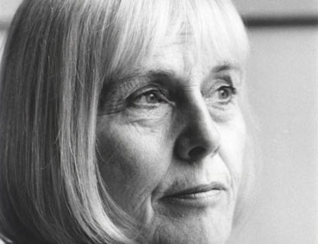

Joan was born in Edinburgh but when she was two years old she went to live in Belfast and stayed there until she was eighteen. Joan started to write when she was eleven years old. She was an avid reader and could never get enough to read. Her local children's library was small, the size of a shed or a garage, and she was soon able to read through what they had on offer.

Over the years Joan has written a number of books set in Edinburgh including “What to do about Holly”. Joan is married with three daughters and five grandchildren.

Visit the website www.**joanlingard**.co.uk/