**J.K. Rowling**

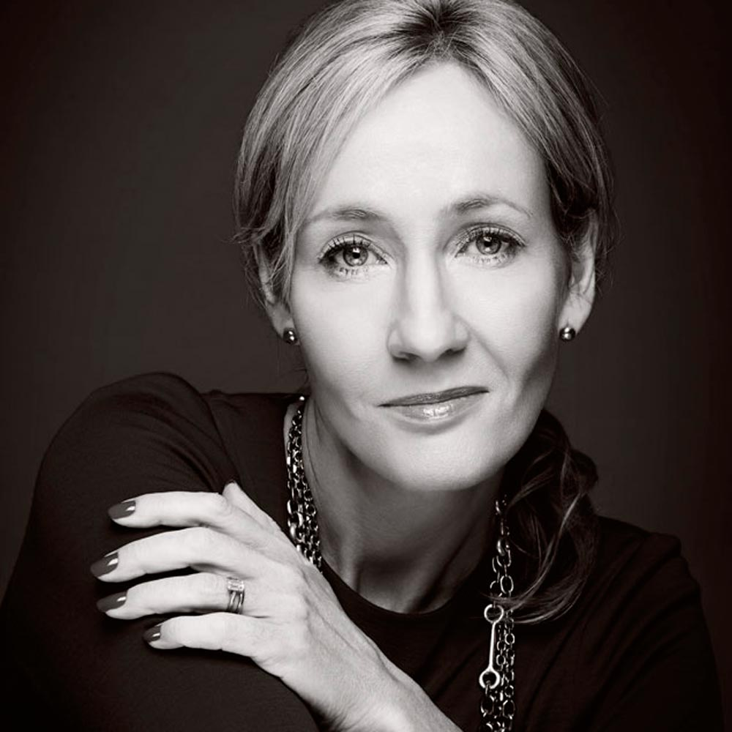

J.K. (Joanne Kathleen) Rowling was born in 1965 at Yate General Hospital in England and grew up in Chepstow, Gwent where she went to Wyedean Comprehensive. Jo left Chepstow for Exeter University, where she earned a French and Classics degree, and where her course included one year in Paris. She started writing the Harry Potter series during a Manchester to London Kings Cross train journey and during the next five years, outlined the plots for each book and began writing the first novel. Jo then moved to northern Portugal, where she taught English as a foreign language. She married in October 1992 and gave birth to her daughter, Jessica, in 1993. When her marriage ended, she returned to the UK to live in Edinburgh. It was while there that the first in the Harry Potter series "Harry Potter and the Philosopher’s Stone” was published in 1997 by Bloomsbury Books.

Visit the website [**www.jkrowling.com**](http://www.jkrowling.com/)