**Chris Mould**

[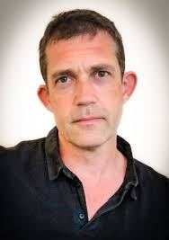](https://www.google.co.uk/url?sa=i&rct=j&q=&esrc=s&source=images&cd=&cad=rja&uact=8&ved=0ahUKEwi5uPPV7MjRAhUGrRoKHYIwB0YQjRwIBw&url=https://www.watermarkgallery.co.uk/childrens-illustrators/chris-mould/&psig=AFQjCNEh3BgJjoZdgOaIwNGjRclSKIQnLA&ust=1484731134998571)

Chris Mould went to art school at sixteen straight from school. While there he did various jobs-washing dishes, delivering papers and cooking in a kitchen. He soon realised he wanted to illustrate as a full-time career.

He has won the Nottingham Children’s Book Award. He likes to write and draw the type of books he would have liked to have had as a child. He is married with two children and lives in Yorkshire.