**Angie Sage**

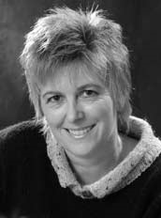

Angie Sage was born in London and grew up in the Thames Valley, London, and Kent. She now lives in Somerset in a very old house that has a secret tunnel below it. Angie is the author of Septimus Heap series as well as the Araminta Spook books

Angie’s own house is home to three [ghosts](http://www.kidzworld.com/article/913-scary-places-1-tower-of-london) - but they are quite shy! She made a living as an illustrator before she made the move into writing. Angie also owns a boat named Muriel, just like the one in the Septimus Heap books.

She has two daughters. Her favourite book to read to them when they were kids was Where the Wild Things Are by Maurice Sendak. Her [favorite colour](http://www.kidzworld.com/quiz/3306-quiz-the-power-of-color) is blue.