**Activities for…  
Wolf by Tommy Donbavand**

**Activity 1** Colour in the werewolf

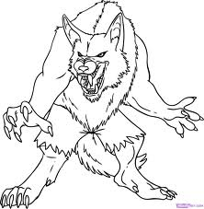

**Activity 2**

Research the myth of werewolves on the internet and in books. Write an account of where this myth originates from.

**Activity 3**

The book finishes with a cliff-hanger. Write what you think would happen next in the story.

**Websites**: [**www.tommydonbavand.com**](http://www.tommydonbavand.com/)

**www.fantasticfiction.co.uk**