**Activities for…  
The World of Norm: May Contain Nuts by Jonathan Meres**

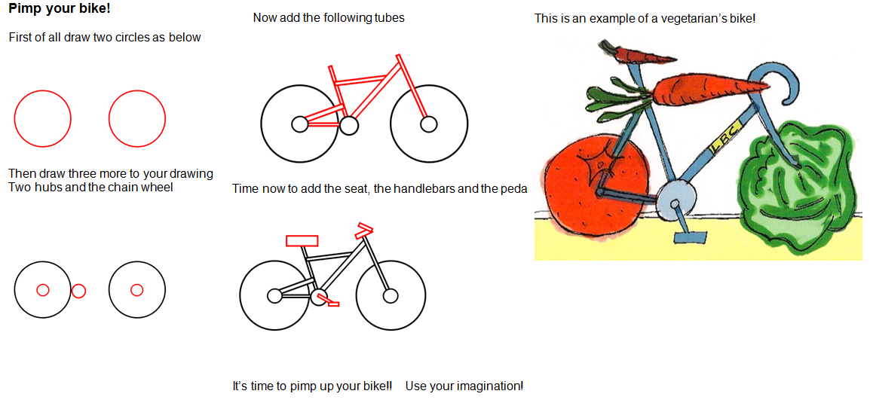

**Activities for…  
The World of Norm: May Contain Nuts by Jonathan Meres**

**Activity 2**

Norm imagines what he would do with the “borrowed”£100. 

What would you do? Use your imagination!

Write a story or draw a story board explaining how you found the “borrowed” money and what you would like to do with it. Explain what happens when your family/friends find out. Does your story have a happy ending?



**Activities for…  
The World of Norm: May Contain Nuts by Jonathan Meres**

**Activity 3**

You have just moved house. Design your ideal bedroom.

