**John Fardell**

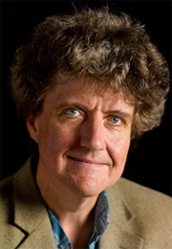

As well as being an award winning author and illustrator, John Fardell is also a cartoonist and puppeteer. John is originally from Bristol but has lived in Edinburgh since 1992. He writes his stories from a garage studio at the side of his house. His first picture book for younger readers was “Manfred the Baddie”, which in 2009 won the Royal Mail Scottish Children’s Book Awards, and then in 2013, he won The Scottish Children’s Book Awards for “The Day Louis Got Eaten”. John lives in Edinburgh and has two sons. If you enjoyed the “The 7 Professors of the Far North”, you’ll love the other books in the series, which are “The Flight of the Silver Turtle” and “The Secret of the Black Moon Moth”.