**C.S. Lewis**

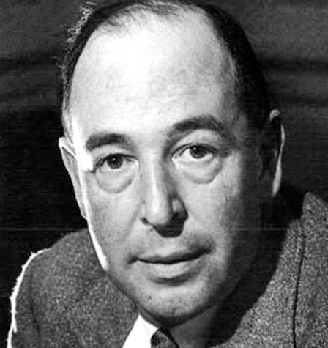

C. S. Lewis was born in Northern Ireland in 1898. He studied at Oxford University in England. He was a soldier in World War I (1914-1918). As well as being a writer, for most of his life he worked as a professor, teaching university students at Oxford and Cambridge.

He married in 1957 and died in 1963. He is famous for writing the Chronicles of Narnia series which has been translated into more than 45 different languages.