**Activities for…  
White Dolphin by Gill Lewis**

**Activity 1**

Dolphins have many important body parts. Try drawing a line to match the part on the left to its use or function on the right

**DORSAL FIN** Dolphins have about 90 sharp ones used to catch their food.

**BLOW HOLE** Used to see both under and above the water.

**PEDUNCLE** Fin on top of dolphin use to help keep them swimming straight.

**TEETH** Sometimes called the beak. Porpoises do not have this feature.

**TAIL FLUKES** Used for breathing and making sounds.

**PECTORAL FIN** Allows the dolphin to hear underwater.

**EAR SLIT** Located in front of the blowhole and used in echolocation.

**ROSTRUM** The back portion of the dolphin containing powerful swimming muscles.

**EYE** Fin used for steering and breaking.

**MELON** Pushed up and down by the dolphin for swimming and jumping.

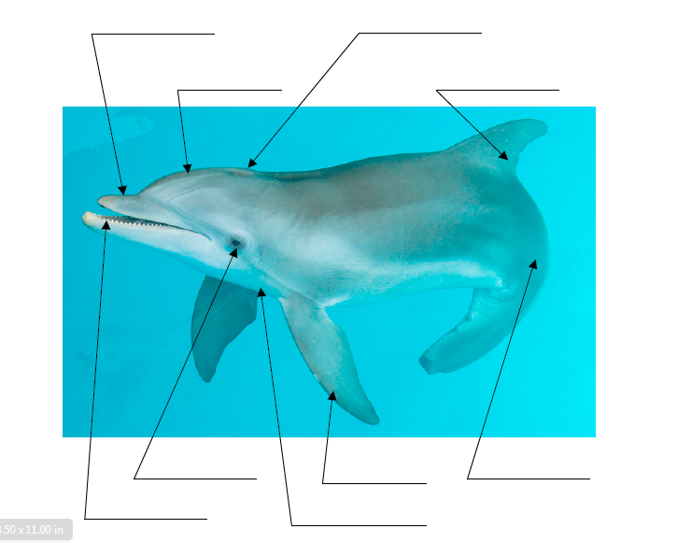

**Activities for…  
White Dolphin by Gill Lewis**

**Activity 2**

Next, see if you can label the parts of Winter

(an Atlantic bottlenose dolphin) in the blanks below.

Did you notice that Winter is missing one of her parts?

**Activities for…  
White Dolphin by Gill Lewis**

**Activity 3**

Sketch the outline of a dolphin onto your paper, or draw around a dolphin template.

Paint the paper with water, leaving the dolphin dry.

If you add a tiny bit of paint to the water it will be easier to see where you have painted.

Water down your paints so they are very runny.

Dab them on to the paper and enjoy watching them run and blend together.

When you are happy with the paint, sprinkle with salt and leave to dry.

Brush the salt off once the paint is dry.

You will find that it absorbed some of the paint and has left a mottled effect, like sea bubbles.