**Activities for…  
Trolls Go Home by Alan MacDonald**

**Activity 1**

Make a Paper Plate Troll

**Instructions**

* Paint the bottom of the paper plate grey, green or brown.
* Colour and cut out the template pieces.  Glue the pieces to the plate to make a troll face:
  + Glue the ears onto the sides of the face.
  + Glue the hair onto the centre top of the plate.
  + Glue the mouth at the bottom of the plate -- you can position the tusk/teeth pointing up or pointing down.
  + Glue the nose above the mouth.
  + Glue the eyes above the nose.
  + Glue the eyebrows above the eyes.

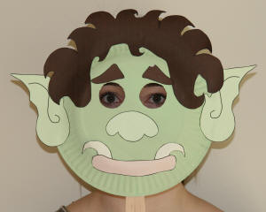



**Activities for…  
Trolls Go Home by Alan MacDonald**

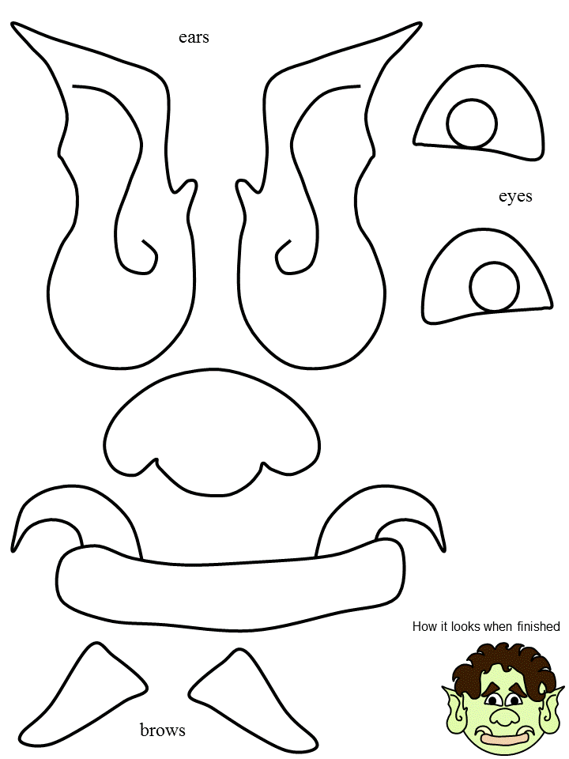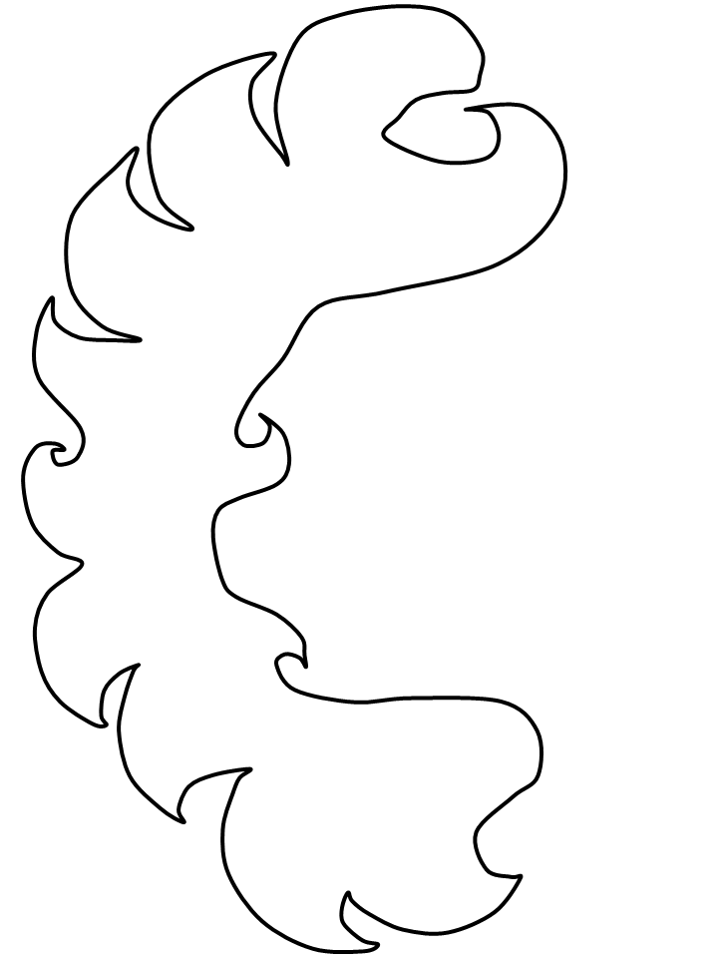

**Activities for…  
Trolls Go Home by Alan MacDonald**

**Activity 2**

Dinner is served! Create a dinner menu for the trolls.

**Activity 3**

Design a troll’s bedroom. What would it look like? What would be in it?

**All about Trolls**

* Trolls are said to have descended from the giants of ancient Norse history.
* Trolls are very large and ugly. They have large feet and a very good sense of smell and hearing but poor eyesight.
* Trolls are extremely strong but not clever.
* Trolls hate the noise of church bells and throw boulders at churches but always miss the target.
* They hoard gold and jewels because they like to look at them.