# Activities for… The No. 1 Car Spotter and the Firebird by Atinuke

|  |  |  |  |  |  |  |  |  |  |  |  |
| --- | --- | --- | --- | --- | --- | --- | --- | --- | --- | --- | --- |
| C | O | R | O | L | L | A | P | Z | F | Q | A |
| T | R | Y | I | X | Z | M | K | L | I | D | O |
| B | H | J | T | B | V | Z | W | K | R | W | R |
| X | D | S | P | O | R | S | C | H | E | M | Z |
| I | D | U | A | F | G | J | K | O | B | B | D |
| V | R | Z | S | T | M | W | S | L | I | R | L |
| P | L | U | S | W | Y | L | W | S | R | S | P |
| W | V | K | A | P | R | M | T | X | D | R | V |
| Y | C | I | T | Y | L | V | L | A | W | C | G |
| A | S | T | O | N | M | A | R | T | I | N | Y |
| L | T | G | W | A | S | Y | A | Y | P | F | J |
| S | E | D | E | C | R | E | M | W | S | L | V |

**Activity 1**

Car Spotter Word Search

Aston Martin Firebird

Audi Mercedes

BMW Passat

Corolla Porsche

Fiat Suzuki

# Activities for… The No. 1 Car Spotter and the Firebird by Atinuke

**Activity 2**

Mama Coca-Cola plays a big part in the story. Can you make a list of other fizzy drinks? Invent some for the letters you don’t know. Someday it might be a bestseller in the supermarket!

A L W

B M X

C N Y

D O Z

E P

F Q

G R

H S

I T

J U

K V

# Activities for… The No. 1 Car Spotter and the Firebird by Atinuke

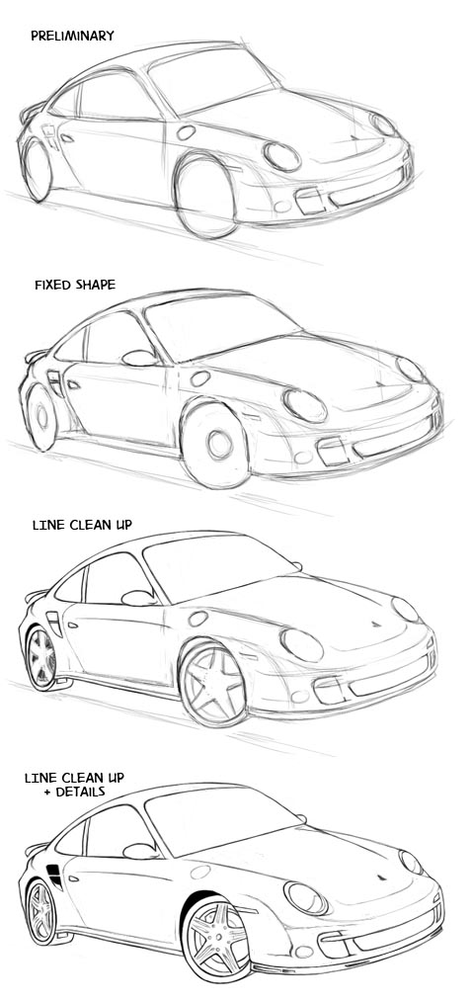

**Activity 3**

Design a car

Design your very own car. What special features would it have?

How fast could it travel?

What colour would it be?

Have a look at:

<https://www.toyota.co.jp/en/kids/car/design.html>