**Activities for…  
Desperate Journey by Kathleen Fidler**

**Activity 1**

DESCRIPTION OF THE MURRAY'S CROFT FROM DESPERATE JOURNEY

There were two rooms to the small cottage. One had a fire on a rough hearth by the wall. Along the side wall between the two rooms was a box bed where James and his wife slept. The small room beyond was almost taken up by the children's two wooden beds. Built on to the end of the house was a shed which housed the horse, the cows and the few hens. The Murray family felt themselves rich because they had a horse. Many crofters had only a cow which they harnessed to the plough when they wanted to turn over the soil of the small fields where they grew their oats and barley.

The little croft was almost self-supporting, with milk and butter from the cows; eggs from the hens; smoked bacon from the pig they fattened and killed each year; and the salt mutton from the few sheep which also provided Kate Murray with wool for her spinning wheel. Kale, turnips and potatoes provided vegetables for the stew-pot; the oats, oatmeal for the porridge. On a quiet evening James Murray took out his boat to catch fish. The Murrays all worked hard on the croft and in the fields, but it was ahappy satisfying life. The children herded the sheep and cows on the hill-side and helped their father to weed his small fieldson the flat ground by the Lundie Burn, which ran past their door.

Make a list of the things you would like and would not like about living on a croft.

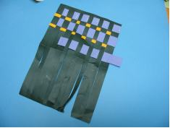

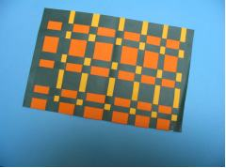

**Activity 2**

Paper Tartan

Choose 3 - 4 different colours of paper. Fold paper in two and using a ruler mark a repeating pattern of small and wide dots along the top. Use the dots to guide where to cut using a guillotine. Stop about 1 cm from the end.

Your paper should look like this. Cut strips of paper of varying width with the guillotine. Weave in and out in a repeating pattern

**Activities for…  
Desperate Journey by Kathleen Fidler**

**Activity 3**

The Murrays emigrate from Scotland to Canada. Do people still emigrate today? Can anyone go to live anywhere they choose? Why not? Choose a country to which you would like to emigrate. Write about all the things you would need to do to prepare for your journey.

**Activities for…  
Desperate Journey by Kathleen Fidler**