**Activities for…  
The Boy in the Biscuit Tin by Heather Dyer**

**Activity 1**

Research some famous magicians, past or present and write a little paragraph about them.

**Activity 2**

Practice a magic trick and perform it in front of the class.

**Activity 3**

Word Search below



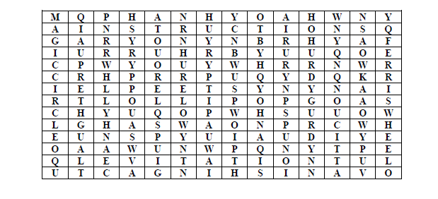

**Activities for…  
The Boy in the Biscuit Tin by Heather Dyer**