**Ted Hughes**

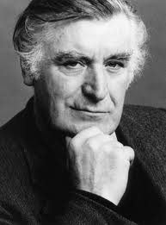

Ted Hughes was born in Yorkshire on August 17th 1930 and died on October 28th 1998.

He lived in Yorkshire during his childhood but as a young man he joined the Royal Air Force. After two years of service, he went to college and studied Anthropology and Archaeology. After he graduated he married Sylvia Plath, who became a very famous poet. They moved to the USA in the 1950s and Ted Hughes taught at Massachusetts University.

Ted Hughes was married three times and had three children.

He wrote many poems and stories for children and adults, one of his most famous being “The Iron Man”, which was published in 1968. Ted Hughes was awarded many literary prizes during his career including the title of Poet Laureate in 1984.