**Stuart Gibbs**

[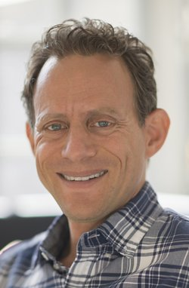](http://www.google.co.uk/url?sa=i&rct=j&q=&source=imgres&cd=&cad=rja&uact=8&ved=0ahUKEwjI56e1kN_NAhVJIcAKHf4HAJMQjRwIBw&url=http://www.amazon.com/Stuart-Gibbs/e/B002R6255S&psig=AFQjCNH2am9QpibWl6D-Iy-s_WLE_v0wFg&ust=1467904469604153)

Stuart Gibbs was born on 11th June 1969 in Philadelphia.

He now lives in Los Angeles with his wife and children. He has wanted to be a writer for as long as he can remember.

He went to the University of Pennsylvania, which he says was “fantastic” and he made some of the best friends anyone could ever ask for there.

Before he wrote novels, he wrote movies and has also worked on many animated projects.

Visit the website [www.stuartgibbs.com](http://www.stuartgibbs.com)