**Sonya Hartnett**

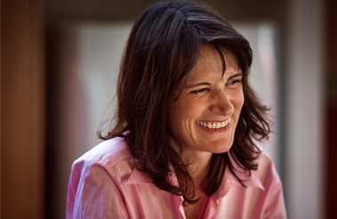

Sonya Hartnett is an Australian author of fiction for adults and children. She has been called “the finest Australian writer of her generation” and had her first book published when she was 15.

Sonya was born on 23rd February 1968 and has three sisters and two brothers. She was a shy child who didn’t like parties and sleepovers. She has won several awards, including Astrid Lindgren Memorial Award, CILIP Carnegie Medal and Guardian Children’s Fiction Prize. She writes on a laptop on her bed for three hours in the morning with coffee, a supply of chocolate and is surrounded by her pets.

In her free time she likes buying houses, doing them up and selling them again. She also spends a lot of time maintaining her fish pond with its 47 fish.