**Activities for…  
Sky Hawk by Gill Lewis**

**Activity 1**

Choose your favourite bird or animal and draw a picture of it. Give a brief description of its characteristics, what it eats and where it lives.

**Activity 2**

Read the sentences below. Use the internet and books to find out about hawks and find the answers.

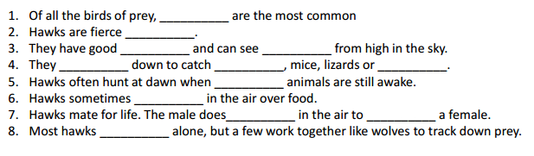

Write them in the empty spaces and find these hidden words in the puzzle below!

**Activities for…  
Sky Hawk by Gill Lewis**

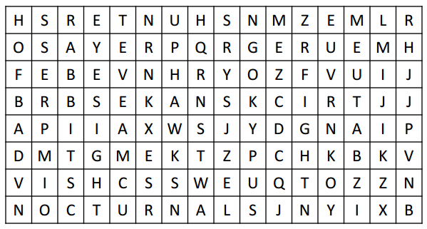

**Activity 3**

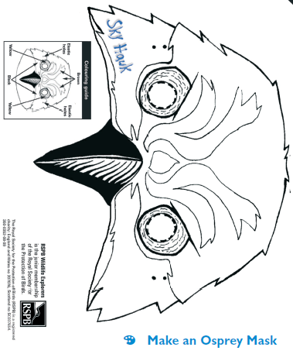

**Activities for…  
Sky Hawk by Gill Lewis**