**Rose Impey**

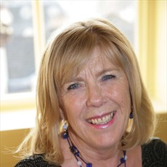

Rose Impey is very well known and highly regarded as a writer of books for children of all ages. It was her experience of telling stories in school as a teacher that led to her starting to write them down. She is a popular visitor to schools and libraries, where she reads her work aloud to captivated audiences. Rose has a deep love and extensive knowledge of fairy and folk tales. For the “Fairy Tales” series (also available in a collection called “The Orchard Book of Fairy Tales”) and for the “Twice Upon a Time” series she thoroughly researched the stories of Grimm, Perrault and Joseph Jacobs before retelling them in her own spirited, direct and authoritative way.

Rose received a great deal of praise for her series “Colour Crackers”, which are lively, funny stories and have the widest possible appeal. “Rhode Island Roy” was read on Jackanory. She has also written stories for picture books. “Joe's Café” won the Sheffield Children's Book Award.