**Roald Dahl**

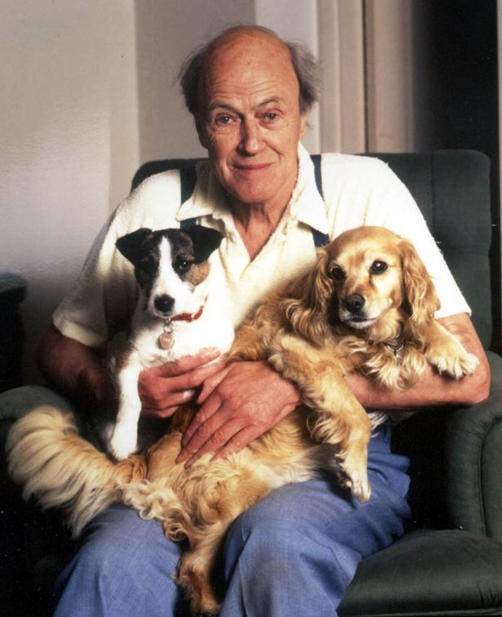

The son of Norwegian parents, Roald Dahl was born in Wales in 1916 and educated at Repton. He was a fighter pilot for the RAF during World War Two, and it was while writing about his experiences during this time, that he started his career as an author.   
  
His fabulously popular children's books are read by children all over the world. Some of his better-known works include James and the Giant Peach, Charlie and the Chocolate Factory, Fantastic Mr Fox, Matilda, The Witches, and The BFG.  
  
He died in November 1990.

[Visit](http://www.google.co.uk/url?sa=t&rct=j&q=roald%20dahl&source=web&cd=1&ved=0CDoQFjAA&url=http%3A%2F%2Fwww.roalddahl.com%2F&ei=o7phT8a5KYOl0AWws_S4CA&usg=AFQjCNFuEcnGHBM-IBTNz6vlwq7RVAYIHw&cad=rja) the websitewww.**roalddahl**.com/