**Rick Riordan**

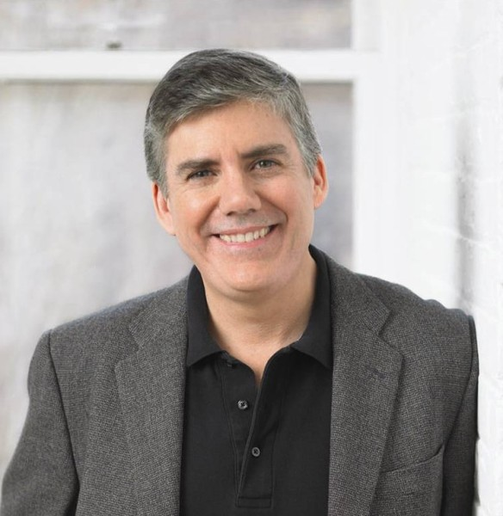

Rick Riordan was born on 5th June 1964 in San Antonio, Texas. He attended Alamo Heights High School in San Antonio and worked as an editor for the school newspaper. He got into trouble for publishing an underground newspaper which made fun of the school, especially the losing football team.

The first book Rick read for fun was the Lord of the Rings. He also liked Greek and Norse mythology. He started writing when he was in High School. When Rick was in college, he worked for three years as the music director at a summer camp, Camp Capers. This was where he got the idea for Camp Half-Blood.