**Psuedonymous Bosch**

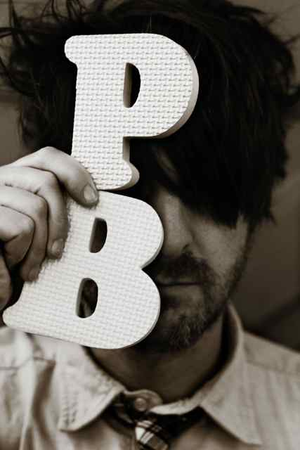

Not much is known of the mysterious Pseudonymous Bosch. However, he does love chocolate and cheese, but hates mayonnaise. On his website he even lists his interests as chocolate, cheese and chess. Pseudonymous Bosch was an avid reader when he was growing up and lists Roald Dahl as one of his favourite authors. Other interests as a child, not surprisingly, include codes and code breaking. He does not have synaesthesia but he does know people who do.

There are five books in the Secrets Series, one for each sense and the human senses feature strongly in the telling of the tales. To find out more, or not very much about Pseudonymous Bosch you can visit <http://www.thenameofthiswebsiteissecret.com/> Author interview at <http://www.youtube.com/watch?v=2ORcM5CK0A0>