**Activities for…  
Out of the Depths by Cathy MacPhail**

**Activity 1**

St Anthony’s College was originally a boarding school for poor boys run by monks. Can you make up a creepy story which took place there?

**Activity 2**

Design a gargoyle.

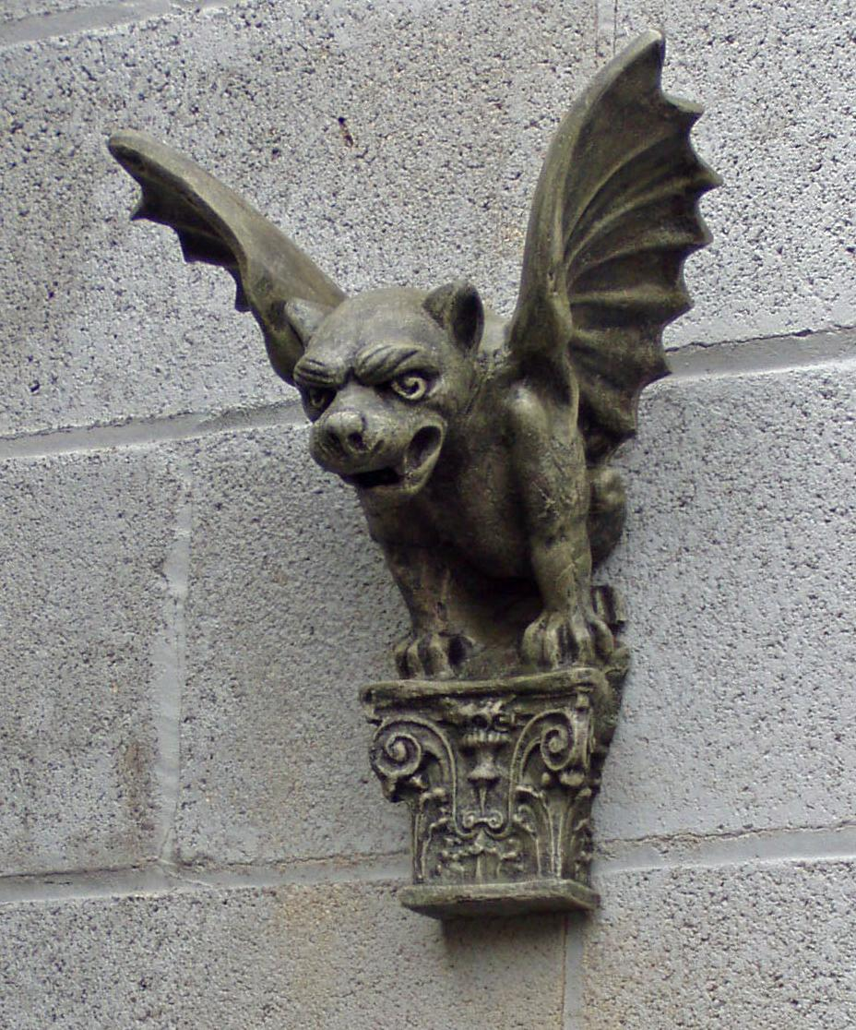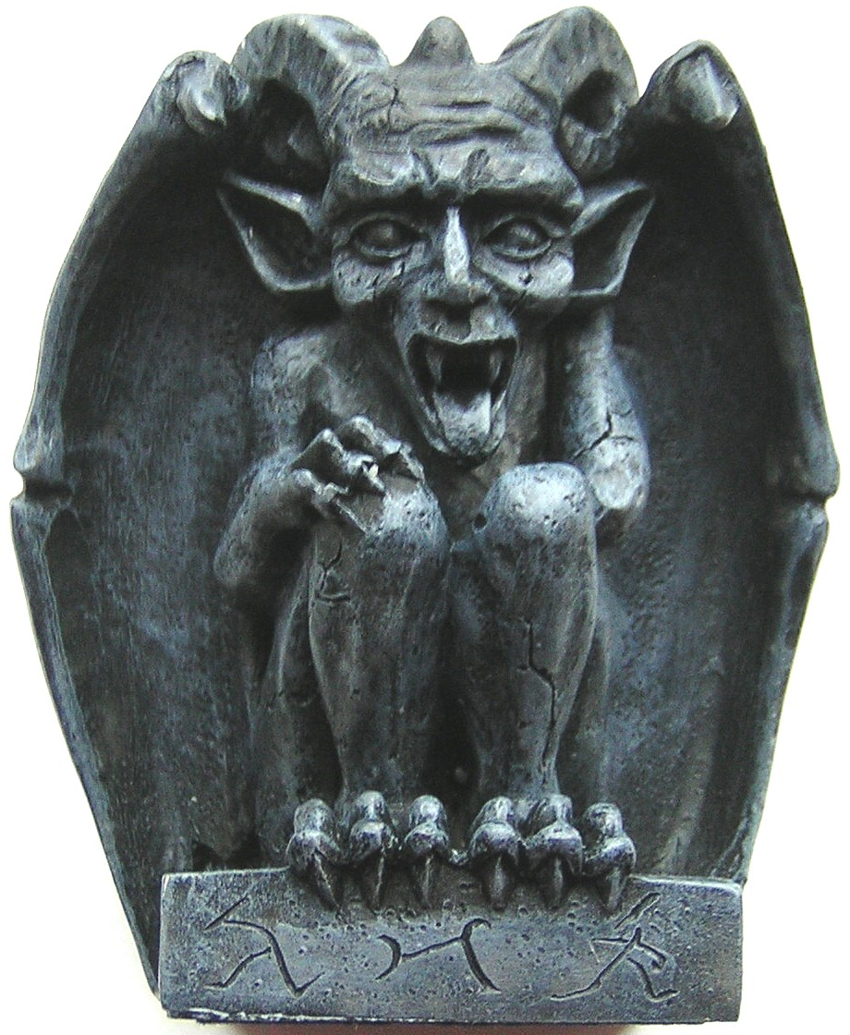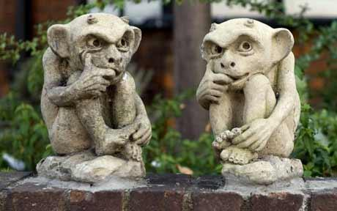

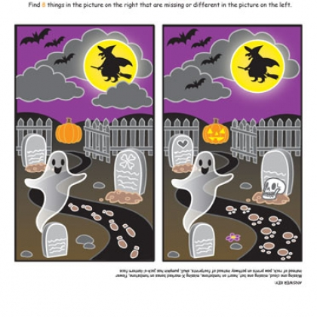

**Activities for…  
Out of the Depths by Cathy MacPhail**

**Activity 3**

Spot the Differences

Find the 8 differences between the pictures