**Activities for…  
Middle School: The worst years of my life by James Patterson**

**Activity 1**

Write your own Middle School short story. Rafe and Leo write and illustrate the Middle School stories together. Why don’t you get together with your best friend and make your own Middle School story?

**Activity 2**

Design your own front cover for this book.

**Activity 3**

Complete the word search below.

**Activities for…  
Middle School: The worst years of my life by James Patterson**

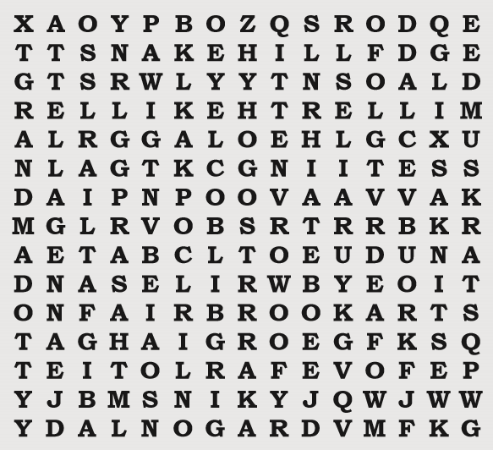

**Activity 3**

Middle School Word Search

