**Michelle Magorian**

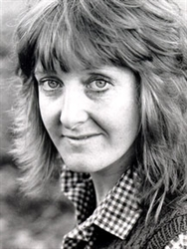

Michelle Magorian was born in Hampshire. As a child she spent as much time as possible in the King’s Theatre in Portsmouth and her ambition was always to go on the stage. She launched into a professional acting career and spent a few years touring all over the country.

Besides acting, Michelle had always enjoyed writing and she wrote *Goodnight Mister Tom* inspired by her mother’s tales about her time as a nurse in the Second World War. It took Michelle four and a half years to write *Goodnight Mister Tom* because she was also working in the theatre. Immediately it was published, it was a huge success, and the story has now been published all over the world.