**Madeleine L’Engle**

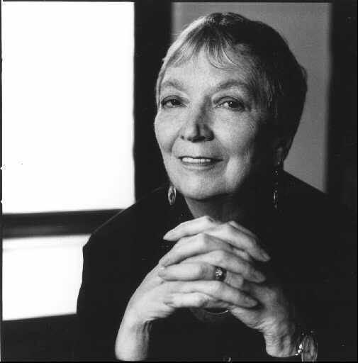

Madeleine L’Engle was born on November 29th 1918 and died on September 6th 2007. L’Engle was an American writer who wrote her first story at the age of five and began keeping a journal at the age of eight.

She is best known for her young adult fiction, in particular the Newbery Medal winning *A Wrinkle in Time* and its sequels; *A Wind in the Door, A Swiftly Tilting Planet, Many Waters* and *An Acceptable Time*. L’Engle’s writing reflects her Christian faith and her interest in science.

To find out more about Madeleine L’Engle visit <http://www.madeleinelengle.com/>.