**Lari Don**

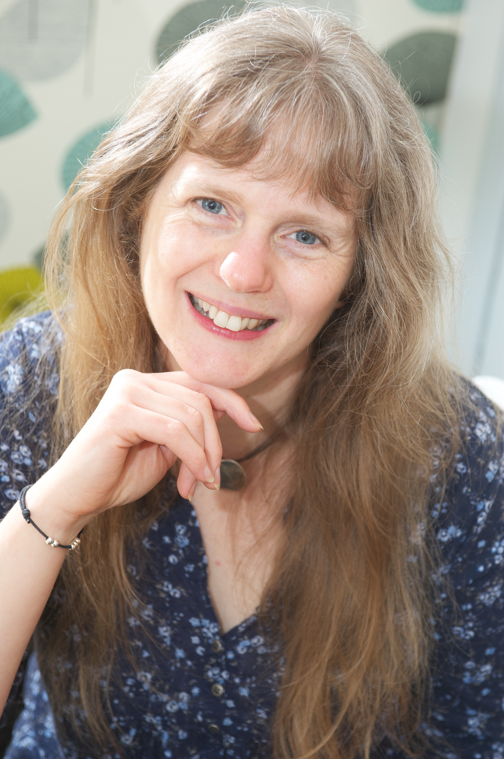

Children's fantasy author, Lari Don was born in Chile, and travelled widely in South and Central America as a child, before her family settled in North East Scotland.

Her first children's book, [First Aid for Fairies](http://www.booksfromscotland.com/Books/First-Aid-For-Fairies-And-Other-Fabled-Beasts-9780863156366) and Other Fabled Beasts, was published in 2008 and won a Royal Mail Award for Scottish Children's Books a year later.

Lari Don now lives in Leith, Edinburgh with her two children, and is a full time author and storyteller.