**L. Frank Baum**

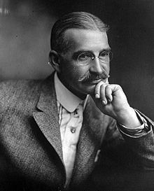

Lyman Frank Baum (the L. stands for Lyman) was born on May 15th 1856 in Chittenango, New York and died on May 6th, 1919 in Hollywood, Los Angeles, California.

Baum was a prolific writer and his many works include thirteen sequels to the adventures in Oz, short stories, non-Oz works, plays and adaptations, as well as works under a pseudonym.

After his death the Oz series was continued by other authors, most notably by Ruth Plumly Thompson who wrote a further nineteen Oz books.