**John Dougherty**

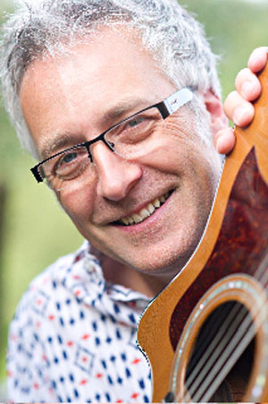

John was born in Larne in Northern Ireland and as a child he always enjoyed reading. This set him on the path to becoming and author and he began writing and illustrating comics in secondary school.

He was a primary teacher for ten years but decided to give this up to follow his dream of becoming an author and has written over ten books to date.

John also enjoys writing poetry and songs and is a keen runner and music lover.