**Activities for…  
I Funny by James Patterson**

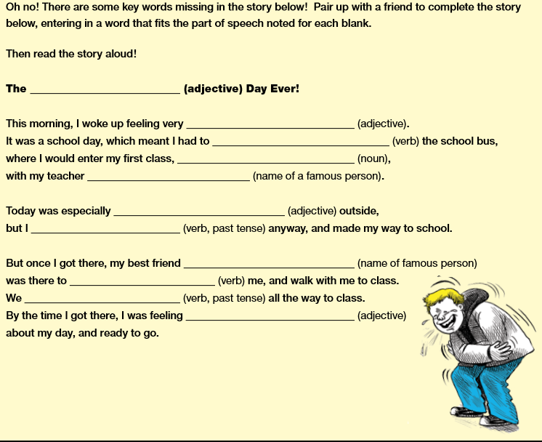

**Activity 1**

**Activities for…  
I Funny by James Patterson**

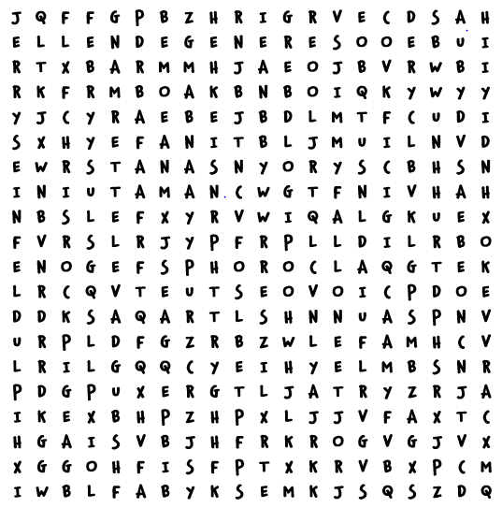

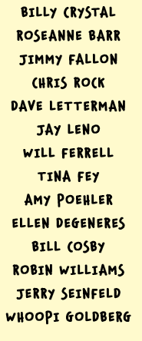

**Activity 2**

Can you find the famous comedy names in this word search?

**Activities for…  
I Funny by James Patterson**

**Activity 3**

What if you had the opportunity, like Jamie, to try your hand as a stand-up comic? Create a poster to promote your one-person stand-up comedy act.

**Activity 4**

Split your classroom into groups of five, and use the list below as inspiration to form mini stand-up comedy groups. Have each group select one of the topics below to prepare a mini stand-up comedy routine to share within the teams. Then, have the teams choose one leader to get up and perform their comedy bit in front of the class.

Topic Suggestions:

Homework Summer Holidays

Brothers/Sisters School Lunch

Parents Video Games

Bullies Zombies

Teachers Junk Food