**Gill Lewis**

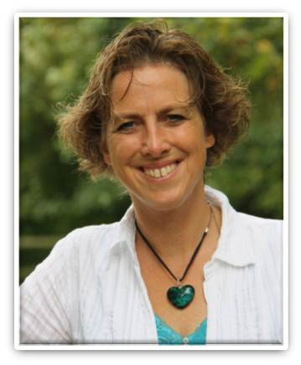

Gill Lewis lives with her husband, three young children and a motley crew of various pets in Somerset. A childhood fascination with anything that crawled, swam or flew led to a career as a vet. Gill began to write and illustrate stories for her own children, inspired by traditional folk-tales and ancient mythologies.

Gill Lewis has a master’s degree in Writing for Young People from Bath Spa University and won the 2009 course prize for the most promising writer. She writes from a shed in the garden, in the company of spiders.