**Activities for…  
First Aid for Fairies by Lari Don**

**Activity 1**

Don’t judge a book by its cover!

* Below are two versions of the book cover. Design and draw your own cover for the book.
* Do you ever judge a book by its cover?

*[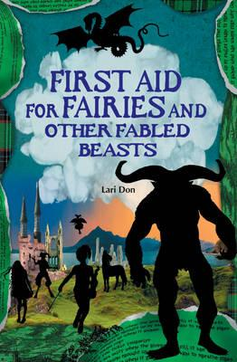](http://www.booksfromscotland.com/Books/First-Aid-For-Fairies-And-Other-Fabled-Beasts-9780863156366) 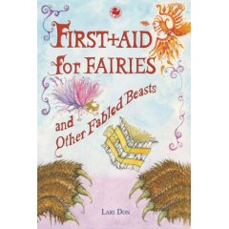*

**Activities for…  
First Aid for Fairies by Lari Don**

**Activity 2**

Draw a cute dragon. Give your dragon a name.

**Activity 3**

Make an origami dragon

http://www.tammyyee.com/origamidpup.html

