**Activities for…  
Fantastic Mr Fox by Roald Dahl**

**Activity 1 Fantastic Fox mask**

**You will need:**

Orange card (or white card and orange paint/orange crayons)  
Template  
Scraps of white and black paper.  
Glue  
3 white or black pipe cleaners   
Elastic

**Instructions:**

Print the [fox mask template](http://www.activityvillage.co.uk/fox_mask_template.htm) directly on to orange card and cut out, or print on to white card, and colour orange.

Draw around the end of the nose on to white paper. Cut out, making the top edge jagged. Glue the white paper on to the orange card.

From black paper cut out two small triangles for the ears and a nose. Glue on the ears.

Take the three pipe cleaners and twist them together in the centre. Glue them to the fox’s nose. Glue the black nose on top. To make everything stick you will have to put a weight on top while the glue dries.

When all the glue is dry, make a hole in either side of the mask and thread though the elastic, tying securely.

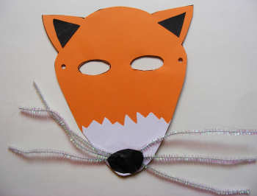

**Activity 2**

Children round about used to sing …

**“Boggis and Bunce and Bean**

**One fat, one short, one lean.**

**These horrible crooks so different in looks**

**Were none the less equally mean”**

Make up different, imaginative names for the greedy farmers.

Draw your characters to suit the names.

**Activities for…  
Fantastic Mr Fox by Roald Dahl**

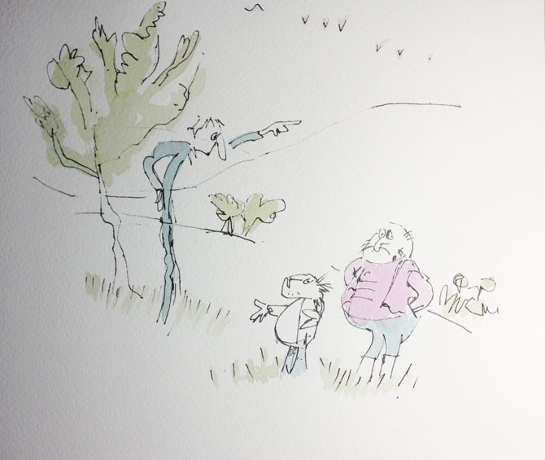

**Activities for…  
Fantastic Mr Fox by Roald Dahl**

**Activity 3** Do you know the answers? Work in pairs.

|  |  |
| --- | --- |
| 1.  _________________ | young, anxious to help their family |
| 2.  _________________ | skinny farmer |

|  |  |
| --- | --- |
| 3.  _________________ | raises turkeys and geese |
| 4.  _________________ | good digger, helps Mr. Fox |

|  |  |
| --- | --- |
| 5.  _________________ | sneaky rodent who drinks hard cider |
| 6.  _________________ | fat chicken farmer |

|  |  |
| --- | --- |
| 7.  _________________ | pot-bellied dwarf |
| 8.  _________________ | drinks gallons of cider |

|  |  |
| --- | --- |
| 9.  _________________ | clever, smart, determined to save his family |
| 10.  _________________ | kind, gentle, worried about her family |

|  |  |
| --- | --- |
| 11.  _________________ | raises turkeys and apples |
| 12.  _________________ | doesn't like to take baths |
| 13.  _________________ | eats three chickens and dumplings morning, noon, and night |
| 14.  _________________ | can't hear well because ears have bugs and wax in them |
| 15.  _________________ | lives on mashed liver which he stuffs in doughnuts |