**Ellen Renner**

[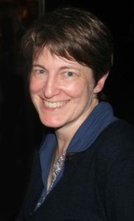](http://www.goodreads.com/photo/author/3182455.Ellen_Renner)

Ellen Renner was born in USA, moved to England in her twenties and now lives in Devon with her husband and son.

She originally trained as a painter and surrounds herself with sketches of her characters as she writes

In her spare time she spins wool, plays the violin, fences, and collects teapots and motorcycles.

Visit the website [www.ellenrenner.com](http://www.ellenrenner.com)