**Activities for…  
Dragonfire by Anne Forbes**

**Activity 1**

Draw a MacArthur. (They wore sheepskin jackets over leggings and tunics)

**Activity 2**

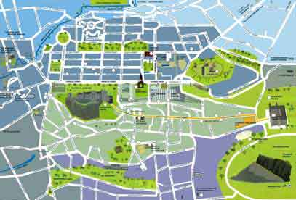

Create your own tourist map of Edinburgh, adding in any extra “inhabitants” you think might live there, including the MacArthurs.

**Activities for…  
Dragonfire by Anne Forbes**

**Activity 3**

Whisky Pipeline

Draw an underground plan showing the route of the whisky from the barrel to the dragon

**Activity 4**

Draw and colour in your own dragon.

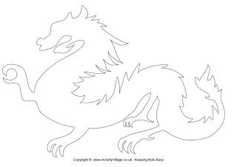

**Activities for…  
Dragonfire by Anne Forbes**

**Activity 5**

Unscramble the names of these precious jewels

MNDAIDO

DMEAERL

LPOA

LPREA

YBRU

TGANER

PPSHAREI