**Activities for…  
Dirty Bertie: Yuck! By Alan MacDonald**

**Activity 1**

Victorian Games

BLINDMAN'S WAND

A variation of Blindman's Bluff, this version uses a stick (the wand) which the other children take turns grasping one end of while the "blind" player (blindfolded) holds the other end. The "blind" player then asks 3 questions to the player holding the opposite end of the stick, and the aim of the game is to recognize the voice of the player who replies. Therefore, the players try to disguise their voices as much as possible. Sometimes, instead of questions, children imitate the sounds of animals e.g. barking like a dog,

CUPID'S COMING

To play this game, first children would have decided upon a letter of the alphabet; for example, the letter "T". The first player would have announced to the second, "Cupid's coming." The second would ask, "How is he coming?" The first responds with a word that begins with the chosen letter, "T", and ends with the ending, "ing", such as, "Tumbling". The game continues from player to player, through all the players, as long as words beginning with "T" (or whatever is the chosen letter), and ending with "ing" can be thought of. Anyone who cannot answer the question on the spur of the moment would have to pay a penalty of some sort, or be ejected from the game, and a new letter would have been chosen.

TWENTY QUESTIONS

This is still a fun game for children to play, but during the Victorian Era, it was a real favourite. To play, one person thinks of a person, place, or thing, and the other players try to guess who or what it is by asking only "yes" and "no" questions. The game continues until the players discover who or what the first person is thinking of, or until twenty questions have been asked -- whichever comes first.

**Activities for…  
Dirty Bertie: Yuck! By Alan MacDonald**

**Activity 2**

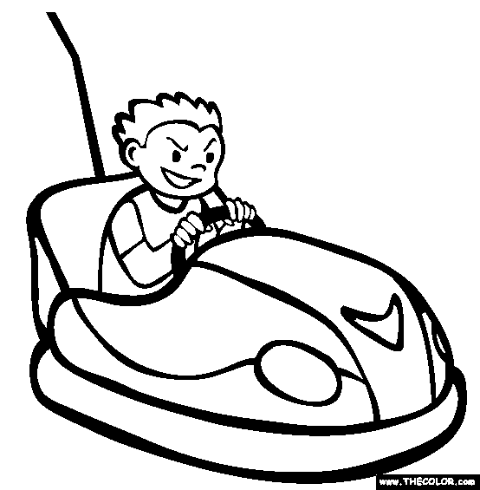

**Activities for…  
Dirty Bertie: Yuck! By Alan MacDonald**

**Activity 3**

**Victorian Word Search**

