**Activities for…  
Dirty Bertie: Fleas! By Alan MacDonald**

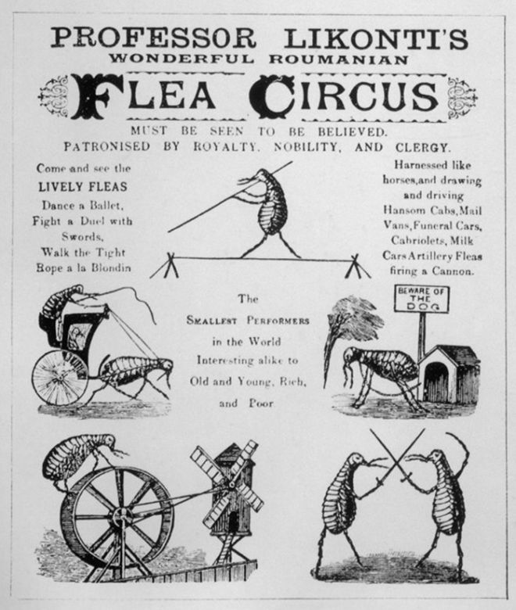

**Activity 1**

A **flea circus** refers to a [circus](http://en.wikipedia.org/wiki/Circus_(performing_art)) [sideshow](http://en.wikipedia.org/wiki/Sideshow) attraction in which [fleas](http://en.wikipedia.org/wiki/Flea) are attached (or appear to be attached) to miniature carts and other items, and encouraged to perform circus acts within a small housing.

Draw your own flea circus. See poster to the left for ideas!

**Activity 2**

Write a story about locking your teacher in a cupboard!

Why did you lock them in? Was it an accident or did you do it on purpose? How long did you leave them there for? Why did you let them out? Did you get into big trouble?

**Activities for…  
Dirty Bertie: Fleas! By Alan MacDonald**



**Activity 3**

Word search

**Activities for…  
Dirty Bertie: Fleas! By Alan MacDonald**