**Activities for…  
Charlie and the chocolate factory by Roald Dahl**

**Activity 1**

Sweet inspiration!

Charlie and the Chocolate Factory

Willy Wonka sold all kinds of wonderful sweets!

* Come up with a new chocolate bar.
* Invent a recipe with instructions
* Design the wrapper for your chocolate bar.
* Invent a slogan to promote the bar.

Example 1 - The Space Bar **Join the race! Eat the Space! Then you'll have a happy face!**

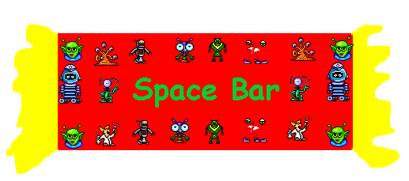

**Activities for…  
Charlie and the chocolate factory by Roald Dahl**

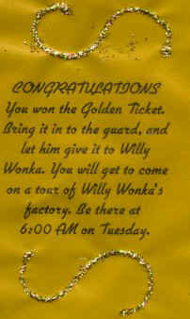

**Activity 2**

Charlie and the Chocolate Factory – The Golden Ticket

Design your own golden ticket to put into your chocolate bar for 5 lucky winners!

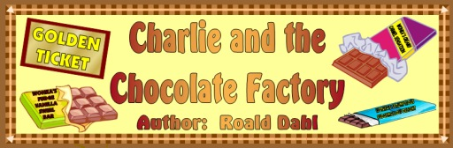

**Activities for…  
Charlie and the chocolate factory by Roald Dahl**

**Activity 3**

Have a go at these Online Quizzes

https://www.roalddahlfans.com/fun-stuff/trivia-quizzes/charlie-and-the-chocolate-factory-quiz/

[www.**roalddahl**.com/](http://www.roalddahl.com/)

<https://www.penguin.co.uk/puffin/articles/are-you-roald-dahls-biggest-fan/>