**Anne Forbes**

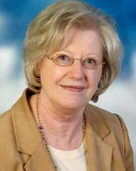

Anne Forbes was born in Edinburgh and trained as a teacher. In 1966, she moved to Kuwait, where she worked for many years in an Anglo-American school.

She currently spends her time between Kuwait and Edinburgh.

Dragonfire, her first published novel, was written years previously and unearthed after her daughter had gone to university.