**Andrew Lane**

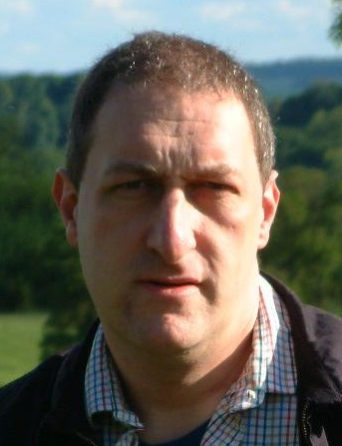

Andrew Lane was born in 1963 and also writes under the name of Andy Lane. He is a British author and journalist and describes himself as a lifelong Sherlock Holmes fan. Andrew lives in Dorset with his wife and son.

He has written spin-off books for many well-known TV shows including Doctor Who and Torchwood. There are 6 books in the Young Sherlock series: Death Cloud, Red Leech, Black Ice, Fire Storm, Snake Bite, and Knife Edge.

To find out more about Andrew Lane and his books go to [**http://www.youngsherlock.com/**](http://www.youngsherlock.com/) where there is also an author interview.