**Alex McCall**

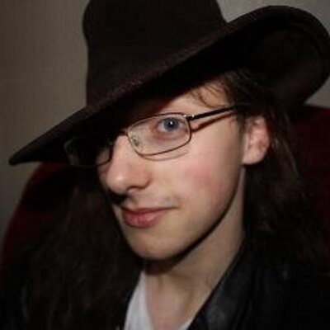

Alex McCall grew up in Aberdeen and is currently studying Filmmaking and Screenwriting at the University of the West of Scotland.

He has been published in several poetry and short story anthologies, and is the winner of the Kelpies Prize 2013.

“Attack of the Giant Robot Chickens” is his first children's book.