**Alan MacDonald**

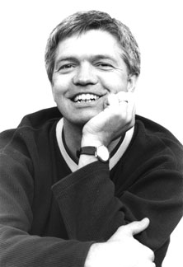

Alan MacDonald was born in Watford. He dreamed of becoming a professional footballer, but when he won a pen in a writing competition, he decided to become an author.

Alan has written over 80 children’s books, which have been translated into many languages and have won several awards. In 2010, Dirty Bertie: Loo was the winner of the Leicestershire Children’s Book Prize.

Alan also writes for TV, including the hugely popular Horrid Henry on CITV.

Visit the website **www.stripespublishing.co.uk**