**David Walliams**

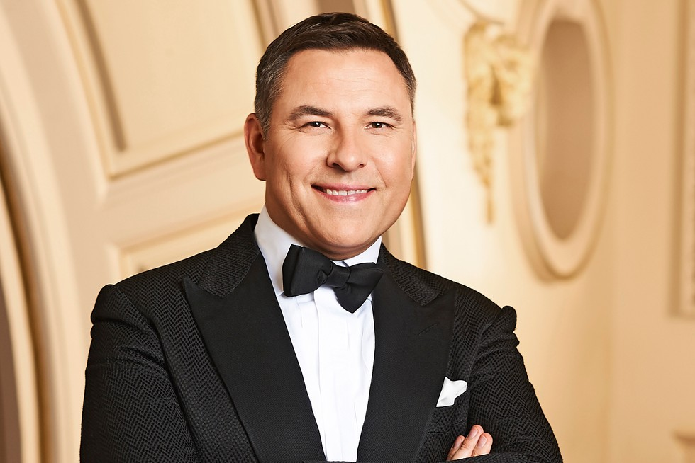



[David Williams](https://www.comedy.co.uk/people/david_williams/" \o "David Williams profile) is an English comic, author, actor and television personality who rose to fame during a double-act partnership with fellow Londoner and comedian [Matt Lucas](https://www.comedy.co.uk/people/matt_lucas/" \o "Matt Lucas profile); most notably in the sketch show *[Little Britain](https://www.comedy.co.uk/tv/little_britain/" \o "Little Britain: 2003 - 2016 BBC Three sketch show with Matt Lucas & David Walliams. Click for a guide.)*.

He has now become better known as a children’s novelist and television talent show judge. But did you know that he’s the biggest selling children’s author to have started writing since the year 2000? Not only that, you can also read his books in over **fifty-four languages**, and he’s sold over **fifty million copies** worldwide! That’s a whole lot of kids, just like you, laughing their pants off around the world!