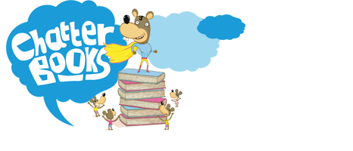
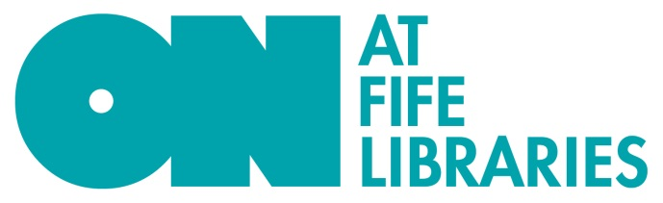
Chatterbooks: FAQs
How do we join?
Just complete the form at the bottom of the main Chatterbooks web page.
How much does it cost?
Normally £50 annually, the introductory membership fee from November 2016 to June 2017 is £35 per Chatterbooks Group. (Alternatively groups can pay £15 per term or £5 per individual collection). Schools can currently only apply to run two Chatterbooks groups. You can pay online or request an invoice.
How do we get the books?
At the start of every term, 3 Chatterbooks sets will be delivered for you. Just let us know which library or school you’d like us to bring them to – it asks for this information on your joining form. You keep all 3 collections for the whole term.
Can we choose the books we want to read?
Yes. We have 130 collections for groups to choose from, and that will grow every month. Just select 10 of your favourites by clicking on the link from the main page of the website. We will deliver two of your choices – plus our hand-picked ‘wildcard recommendation’ - at the start of each term.
How big should our group be?
We recommend that you have no more than 12 children in a group so that everyone feels relaxed and happy to chat.
How often should we meet?
We recommend you meet at least once a month but it’s really up to you. Lots of groups meet every couple of weeks to chat about the book as they read it.
Can we share ideas with other Chatterbooks Groups?
YES! Fife Chatterbooks are affiliated to the Reading Agency so sign up to receive their newsletter and post your own pictures, reviews and comments on their site at www.readingagency.org/chatterbooks
If you have any other questions just drop a line to chatterbooks@onfife.com and we’ll get right back to you.

